Assignment 1
Due: After Unit 3
Total: 100 marks
Weight: 15% of your final grade
Answer all questions in this assignment. Submit your completed work to your Academic Expert for marking and feedback using this Assignment Drop Box.
- (12 marks) Answer the following questions (250 words max/question).
- Define the concept of program-data independence and explain how it is achieved in the database approach. (2 marks)
- Program-data independence is the act of separating program data, called meta data, with the physical storage of data. Data descriptions are stored within a repository, separate from the actual database storage.
- Program-data independence is an important practice as it decouples the two layers, allowing for independent changes, or isolation for troubleshooting.
- Briefly compare and contrast the following development approaches: systems development life cycle and prototyping methodology. You may use a table to list their phases, procedures, and processes, indicating their similarities and differences. (3 marks)
- SDLC is the process of designing, building and maintaining information systems through planning, analysis, design, implementation and maintenance. It’s a software engineering principle that breaks down a larger task into smaller more manageable phases, with specific activities and goals for each phase. Although SDLC is a highly structured approach, there is no one-way for all to build a system, so some flexibility is required, including overlapping of activities and phases.
- Prototype methodology is an iterative process whereby requirements are collected and turned into functioning system that is continually revised through close work.
- Both approaches have their own benefits and drawbacks. SDLC is excellent for professional teams with a lot of experience working on complicated systems with a lot of turnovers. A great deal of analysis and documentation is produced, which increases understanding of a system. However, if requirements collection isn’t performed quite properly, or the problem that’s being solved isn’t fully understood, then time can be lost with SDLC.
- Rapid prototyping, however, gets a product in the users’ hands as quickly as possible. It allows users to evaluate the functioning of a proposed solution and provide direct feedback. Similarly, if the problem isn’t fully understood or if incorrect design decisions are made then development cycles can be lost as well.
- Each system has its benefits and drawbacks, and it really depends on the situation, project and team.
SDLC | Rapid Prototyping
Planning | Identify Problem
Analysis | Develop Initial Protoype
Design | Implement
Implementation | User Evaluation
Maintenance | (if required) Revise and go to Implement
 | Convert to Operational System

- Discuss the differences between entity, instance of an entity, and relationship. (2 marks)
- An entity is the description or definition, or an idea of an object. It will have a name, and define its properties, functions and other attributes.
- An instance of an entity is the physical embodiment or actualization of the entity.
- A relationship is how two or more entities are related within organizational data and a fundamental concept of relational databases. Relationships can include one to none, one to one to many, many to many. Relationships can be used to provide more context of an object, or provide extra information about an object, or even ownership over other objects.
- Explain the three-schema architecture used for database development and list the stakeholders for each schema. (3 marks)
- The three schema architecture was a concept created by a committee called ANSI/SPARC in 1978. It defines the way to describing the structure of data. It separates the organization of data into three layers:
External schema is the schema is how the system data is seen by stakeholders such as managers and other users of the database. It is known as the view layer.
Conceptual schema is the view of the database in a single coherent, comprehensive definition as seen by the database administrator or architect. Known as the logical layer.
Internal schema Describes how data is physically stored: file structures, indexes, storage paths, access methods. Focuses on performance, storage efficiency, and physical organization. Stakeholders: DBAs, system programmers, storage engineers.
- Define and contrast the following terms: database, data warehouse, and data lake. (2 marks)
- Databases are strongly structure systems for storing of operational data. Databases can be of any size and complexity and can be used by a range of users, although typically developers.
- Data warehouses are also strongly structured systems; however they are more designed for reporting or operational decision making and support. Data stored in warehouses is usually modified or adapted to produce faster results, streamlined to business needs.
- Data lakes are raw, unstructured data storage systems that collect data from a range of systems, data source types, storage types and structures. Data lakes do not follow a predefined schema. They’re a new concept, and are raw data storage typically used for large enterprise systems or machine learning, cheap storage is important.
- (12 marks) Give a simple example of an E-R diagram for each concept and then write the business rules for each example.
- associative entity:
This is an example of a recent project I finished, where we were issuing certificates to vessels. There were dozens of types of certificates, and thousands of vessels. A vessel may have one or many types of certificates, and conversely a certificate can be issued to many vessels. I generated the diagram using draw.io
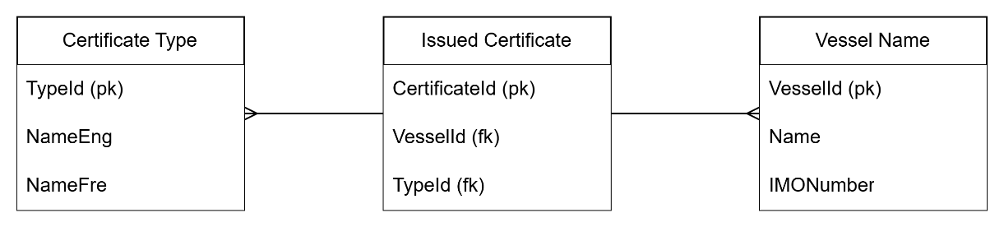
- Weak entity: Continuing with the vessel insurance theme, we see the Vessel Owner is a weak entity. A Vessel Owner may not exist without the Vessel Name entity, but a Vessel Name can exist without a Vessel Owner. The relationship is 1 vessel Name to many Vessel Owner.
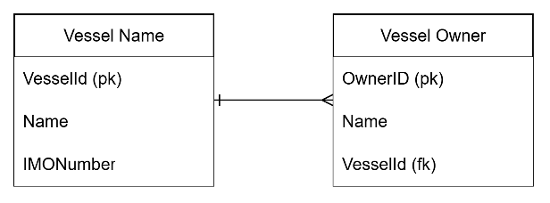
- Unary relationship: Here we see a unary relationship whereby a Ship Officer could report to a another ‘supervisor’ officer, or if they’re the captain, none at all (ie. SuperVisorOfficerId is nullable). A ship office can only have one supervisor, however that supervisor can have its own supervisor, until the captains position is reached.
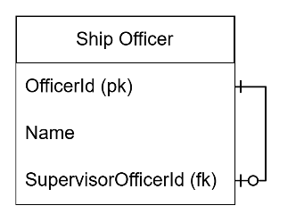

- (17 marks) As an independent consultant, you have a contract with Athabasca University to develop an application to support course administration. Read the detailed description of this application and then complete the tasks that follow.
- A course has a unique course number and title and is assigned to one or more areas of the Computer Science program. Each course has an instructor, at least one teaching or research assistant, an online discussion forum, a delivery period (start date, end date), and a capacity (maximum number of participants). A course need not be offered each term, but the challenge option is open throughout the entire year. A course may have prerequisite courses, and a student is not allowed to register for a course if they have not fulfilled the prerequisites or their equivalent. In addition, a student who would like to challenge a course should have the course prerequisites or authorization from the course instructor.

- An instructor has an employee number, first name, last name, email, phone number, and address and is assigned to several areas of expertise. Note that two different instructors may have the same (first and last) names. Also, instructors may share the same address (e.g., partners living in the same house). Each instructor may have dependents. Each dependent has a first name, last name, gender, and date of birth.
- A student is given a unique student number. The first name and last name, email, phone number, address, and GPA must be recorded for each student. Identical names and addresses may belong to different individuals. A student may be enrolled in several courses each term. The grade must be recorded for each enrollment. There are two types of students: graduate and undergraduate. Undergraduate students have a study major, while graduate students have both a specialization and a thesis topic.
- A teaching assistant is a graduate student. Their first name, last name, year, and GPA must be recorded, as well as the number of courses (including the current ones) the teaching assistant has already taught.
- A research assistant is a student (graduate or undergraduate). In addition to the basic information recorded for a student, the number of years of work experience must be recorded. The research assistant provides laboratory support for students, manages the course discussion forum, and does some programming tasks.
- An area of study is described by its name. An area may be divided into several sub-areas. These areas are used to categorize instructors as well as courses. For example, the area of game development consists of sub-areas such as Graphics, Networking, and Human–Computer Interaction; the area of Data Science consists of Databases, Data Mining, Artificial Intelligence, Machine Learning.
Hint
For each relation without a unique attribute or combination of attributes, introducing an artificial primary key might be a good idea.
- Design an EER diagram for this course administration system. Draw the complete EER diagram, including all aspects discussed in the course. Clearly state any further assumptions made, but keep in mind that you must not override the specifications above. (10 marks)
- Identify and list weak entities and associative entities. (4 marks)
For every supertype/subtype relationship, identify the subtype discriminator and list any eventual disjointness constraint as well as any disjoint rule or overlap rule associated with it. (3 marks)

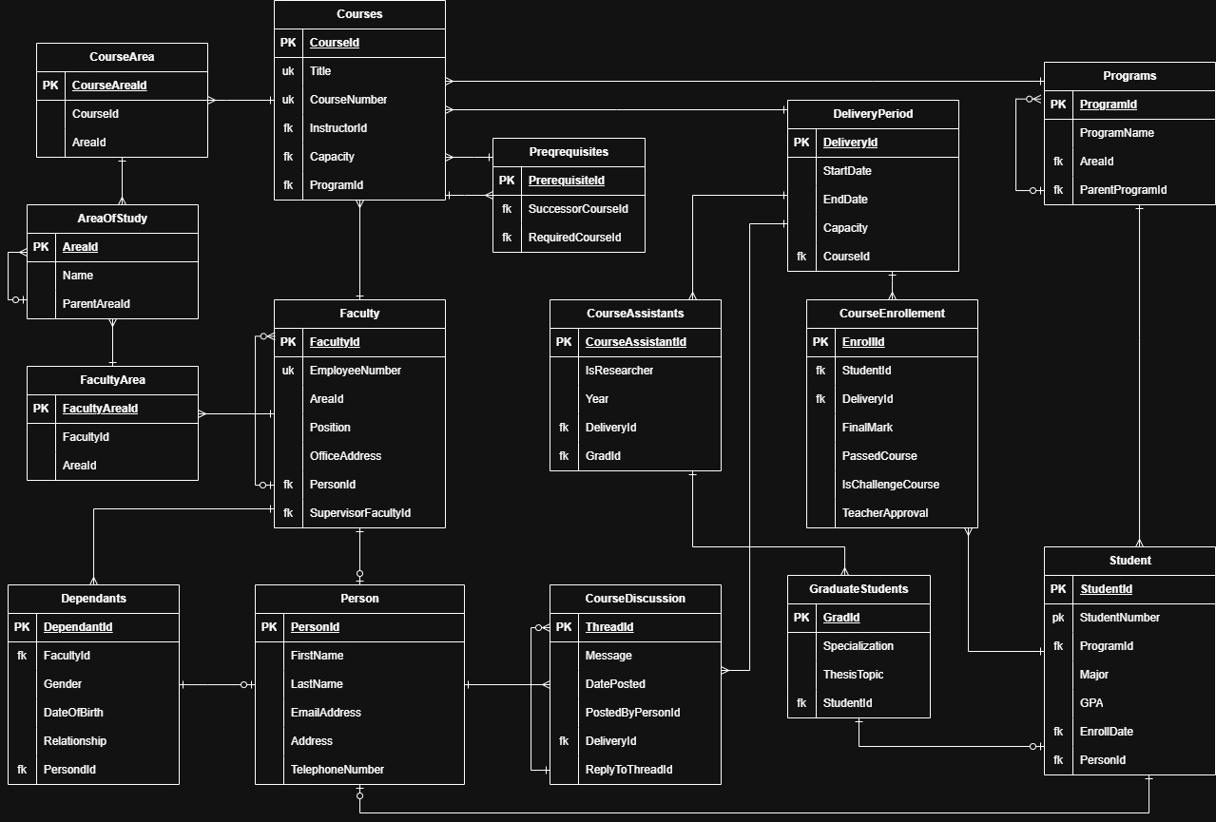

- (17 marks) Transform the following EER diagram into relations and indicate the primary key and foreign keys for each relation.
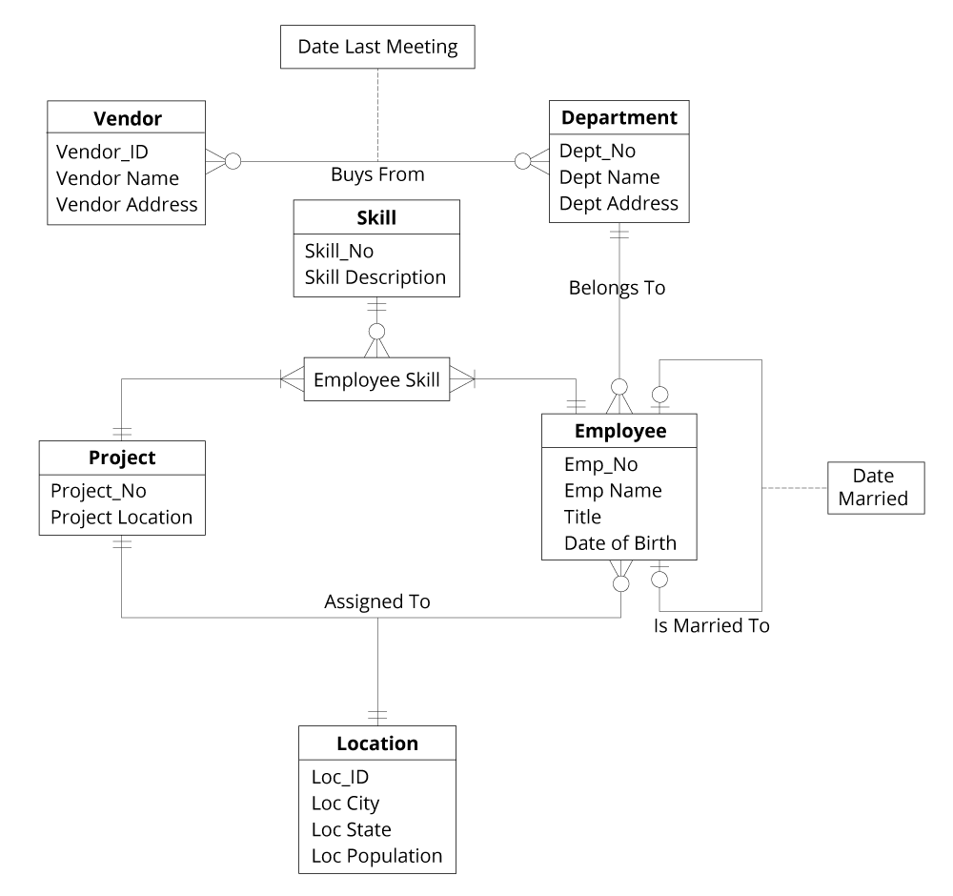
Figure 1: EER diagram
Vendor:
Vendor_ID
Primary Key

Vendor buys from multiple departments
Many to Many - associative
FK: Dept_No

Department:
Dept_No
Primary Key

Dept buys from mulitple vendors
Many to Many
FK: Vendor_Id

Purchases:
Date Late Meeting
Purchase agreement between a vendor and a department
Many to Many
FK: Dept_Id, Vendor_Id

Project:
Project_No
Primary Key
Assigned to exactly one Location
Fk: Loc_ID
Has multiple Employee Skills
PK: Project_No
FK: Skill_No, Emp_No

Locations:
Location_ID
Primary Key
Assigned to exactly one project
One to One
PK: Loc_Id
FK: Project_No
Multiple employees assigned to a location
One to Many
PK: Loc_Id
FK: Emp_No

Employees:
Emp_No
Primary Key
Married to one other employee including marriage date
PK: Emp_No
FK: Emp_No
One to One
Assigned to exactly one department
PK: Emp_No
FK: Dept_No
Many (dept) to one (Employee)
An employee is assigned to a specific location with a specific skill
PK: Emp_No
FK: Project_No, Skill_No

- (12 marks) Consider the following relations:
Employee(E_id: integer, E_name: string, Age: integer, Salary: real)
Works(E_id: integer, Dep_id: integer, Start_date: date)
Department(Dep_id: integer, Dep_name: string, Budget: real, Manager_E_id: integer)
- What referential integrity constraints exist between these relations?
- Every ‘Works’ has one valid ‘Employee’ and ‘Department’
- Every ‘Department’ has one valid ‘Employee’
- What are the options for enforcing these constraints when a user attempts to delete a Dept tuple?
- Delete a ‘Department’ would cause a FK constraint on ‘Works' if any ‘Works’refers to ‘Department’.
- Options to force the deletion could be:
- CASCADE: delete the ‘Works’ entity referring to ‘Department’
- NULLIFY: If Works allows null values, set to null
- DEFAULT: If works has a default value (with a valid ‘Department’) replace the default value
- (13 marks) For each of the following relations, list the functional dependencies between attributes and transform it into 1NF, 2NF, and 3NF. During the transformation to each of the normal forms, justify any decomposition.
- Consider the relation STUDENT, where a student can have only one major and stuID is a unique identifier for students:
RELATION = STUDENT (StuID, StuName, Address, Birth_date, Gender, Major)
The only functional depenancy is StuID -> StuName, Addrss, Birth_Date, Gender, Major. WE are told that StuId is the unique identifier, so all other attributes can be determined using StuId. There are no other dependanices.
1NF: In order for a relation to be in 1NF there must not be any repeating groups in the relation and a primary key is defined, uniquely identifying each row.
For STUDENT, we’re told stuID is the unique identifier for this row. The rest of the non-repeating group, so the relation is already in 1NF form
2NF: In order for a relation to be 2NF each non-key attribute must be fully functionally dependant on the primary key, stuId. Each other value can be determined directly by referencing stuID and no other key, there are no composite keys and no repetition of data. So this relation is already in 2NF.
3NF: A relation that is 2NF and has no transitive dependencies. This relation is already in 3NF because the other attributes; StuName, Address, Birth_Date, Gender, Major have no dependency on each other, as in no non-attribute key are dependant on the primary key via another non key attribute.
- Consider the relation EMPLOYEE, where an employee can have more than one specialization and more than one dependent. EmpID is a unique identifier for employees and dependent_name is a unique identifier for each employee’s dependents; however, dependents of different employees may have the same name.
RELATION = EMPLOYEE (EmpID, Name, Phone, Email, Address, Specialization, Dependent_name, Dependent_age, Dependent_gender)
The functional dependencies:
- EmpID -> employees’ phone, email, address.
- EmpID -> specializations
- EmpId, Dependent_name -> Dependent_age, and Dependent_gender.
1NF:
Employee(EmpID, Name, Phone, Email, Address)
EmployeeSpecialization(EmpID, Specialization)
EmployeeDependant(EmpId , Dependant_name, Dependant_age, Dependent_gender)
2NF:
Employee(EmpID) has a single attribute key, so it is 2NF
EmployeeSpecialization(EmpID, Specialization) has a composite key, but no other attributes, therefore it must be 2NF.
EmployeeDependant(EmpId, Dependant_name) has a composite key, but neither EmpId or Dependant_name alone can determine a Dependent_age or Dependent_gender, therefor this is 2NF
3NF:
Employee: Name, phone, email, address cannot determine EmpId, so this table is already 3NF.
EmployeeSpecialization: Has no non-key attributes, therefor it is 3NF already.
EmployeeDependent: Dependent_age, or Dependent_Gender cannot determine Dependnt_Name or EmpId, therefor this table is already 3NF.

- (17 marks) Consider a one-relation database with the following attributes:
Employee number (emp_no), Date hired (date), Job title (job), Phone number (phone_no), Office number (office_no), Area (area), Salary (sal), Project number (proj_no), Project budget (p_budget), Department number (dep_no), Department budget (d_budget), and Department manager employee number (mgr_emp_no).
Transform this relation into 3NF using only the attributes and functional dependencies listed in the question. Justify any decomposition.
The following business rules apply:
- No employee can manage more than one department at a time.
- No employee can work in more than one department at a time.
- No employee can work on more than one project at a time.
- No employee can have more than one office at a time.
- No employee can have more than one phone at a time.
- No employee can have more than one job at a time.
- No project can be assigned to more than one department at a time.
- No office can be assigned to more than one department at a time.
- Department numbers, employee numbers, project numbers, office numbers, and phone numbers are all globally unique.
The following functional dependencies also apply:
- emp_no → phone, emp_no → office_no, emp_no → dep_no, emp_no → proj_no
- {emp_no, date} → job, {emp_no, date} → sal
- phone_no → office_no, office_no → area, office_no → dep_no
- proj_no → dep_no, proj_no → p_budget
- dep_no → mgr_emp_no, dep_no → d_budget
- mgr_emp_no → dep_no

3NF:
Employee
Emp_no, phone_no, office_no, dep_no, proj_no

EmployeeHire
Emp_no, date, job, sal
- This is required because employees can be hired at different times, or their job and salary can change over time.

OfficePhone
Phone_no, office_no
- Since phone_no, office_no are globally unique, and there is a functional dependency of phone_no -> office_no, then this is required to achieve 3NF.

Office
Office_no, area, dep_no
- Since office_no is the unique attribute, then area would belong within here

Project
Proj_no, dep_no, p_budget

Department
Dep_no, d_budget, mgr_emp_no

